Apache Spark

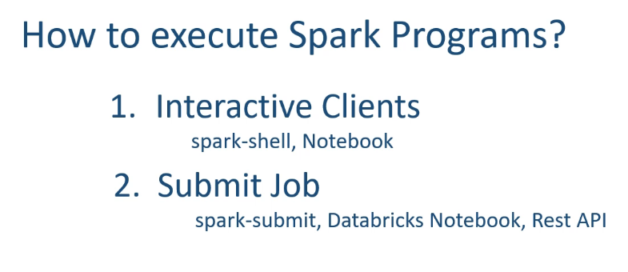

Dataframe: -

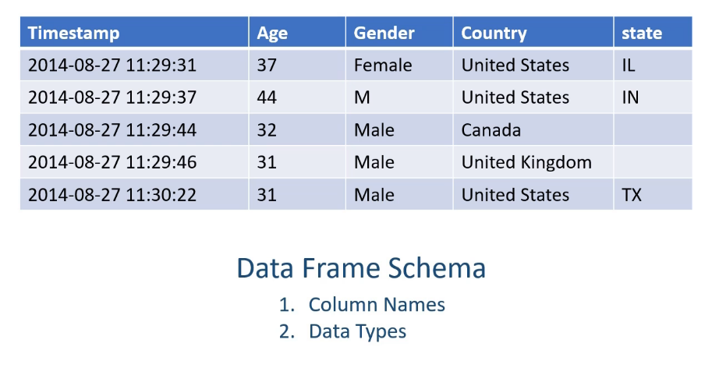

* Spark DataFrames are immutable

Reading a csv file: -

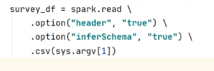

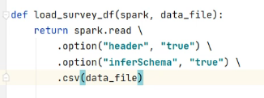

Some transformation examples: -

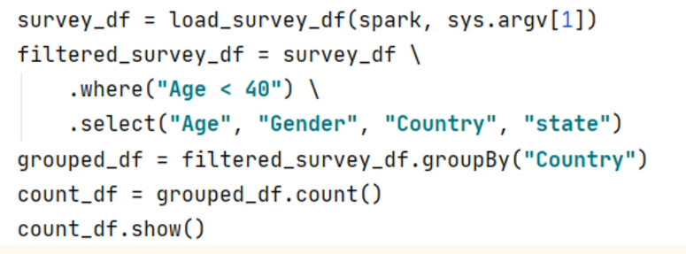

* load_survey_df is a simple Python function for instructors convenience. Don’t focus on it

Spark Operations: -

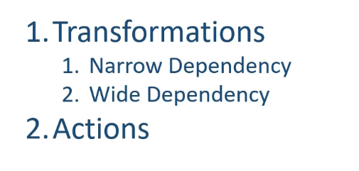

Narrow Dependency Transformation: -

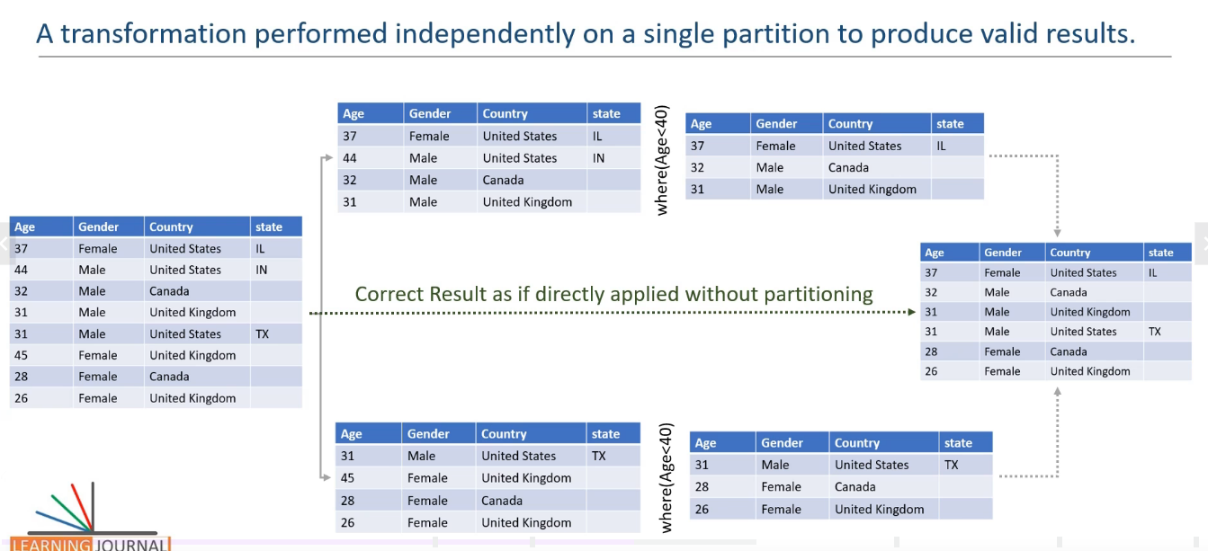

Wide Dependency Transformation: -

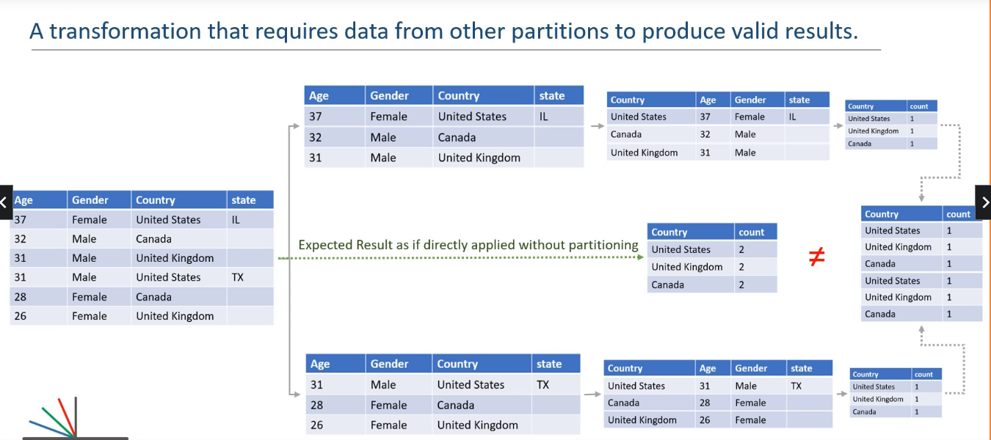

Some Wide Dependency Transformation examples: -

* Group by
* Order by
* Join
* Distinct

How spark performs the group by operation to produce valid output: -

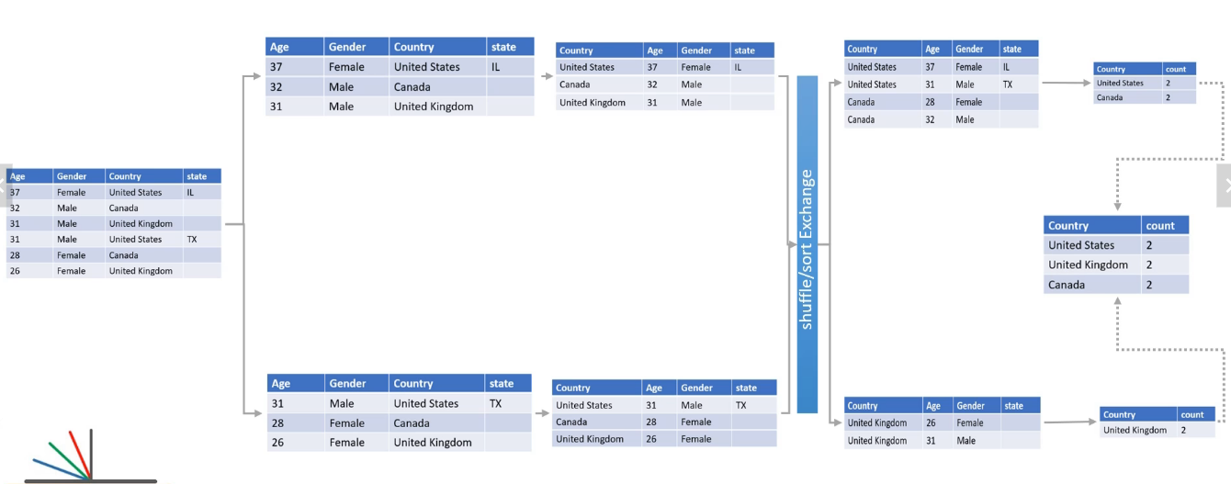

Some spark actions: -

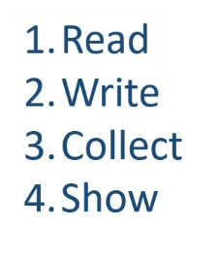

Spark APIS: -

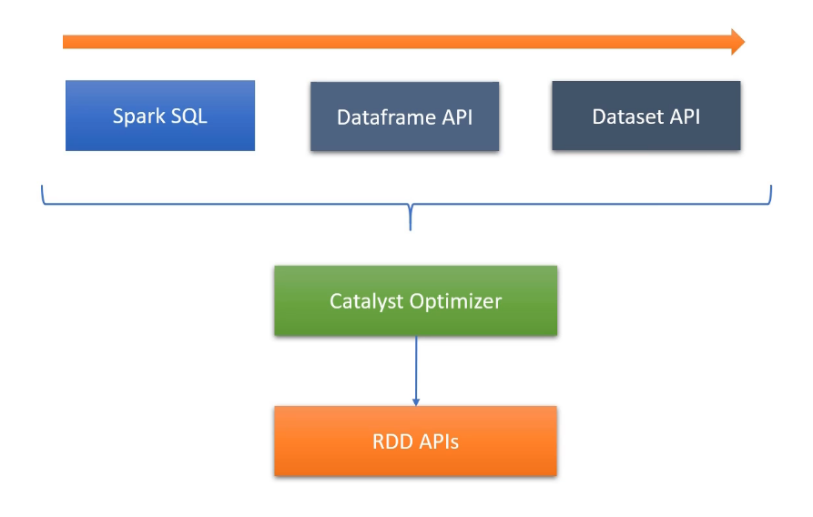

Getting Spark **context** from spark *session*: -

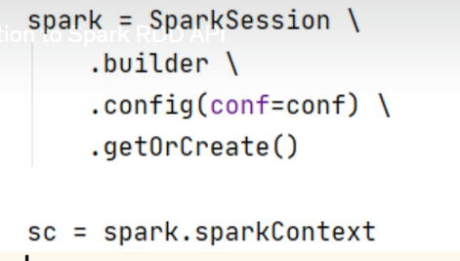

* We need spark context (sc) to use RDD’s

RDD: -

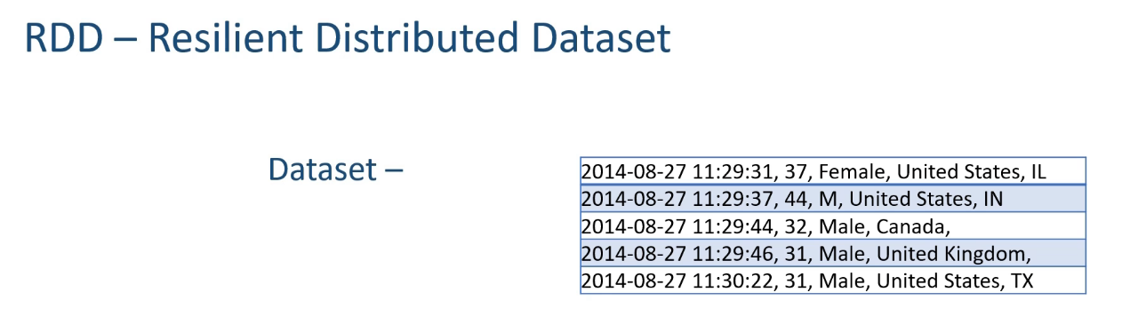

* RDD’s don’t have any row-column structure or Schema, it is just like a python collection
* Each RDD partition comes with the information of How they were created that’s why it is resilient

Creating an RDD: -

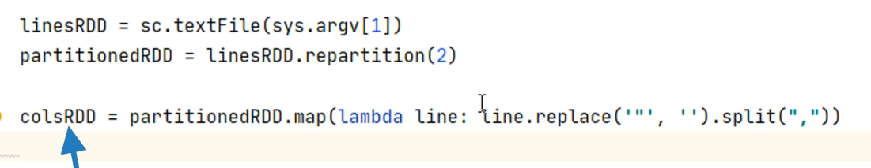

Creating a schema for the RDD: -





Some operations: -

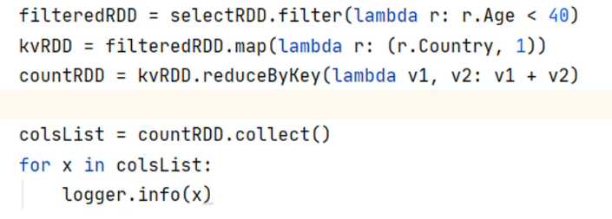

Using spark SQL: -

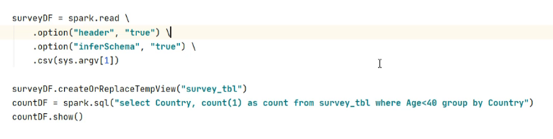

Data sources and Spark: -

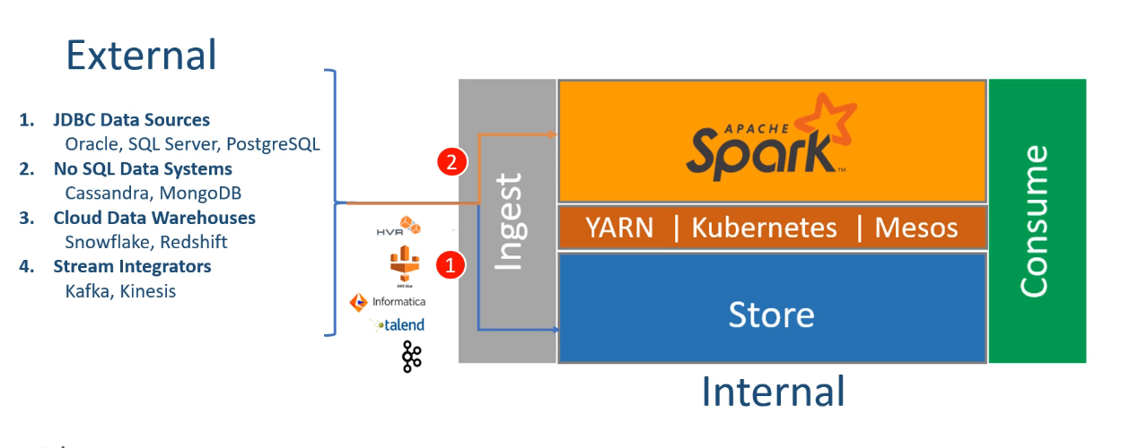

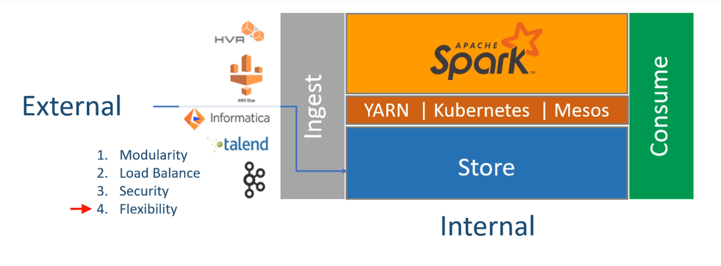

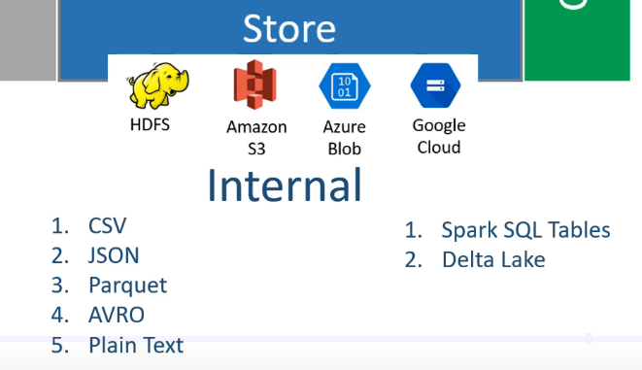

How to read data: -

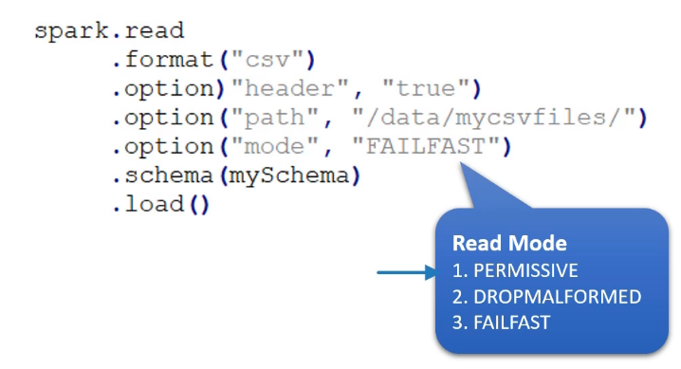

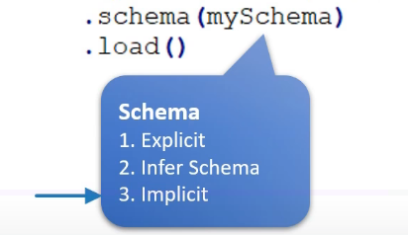

Reading a csv file: -

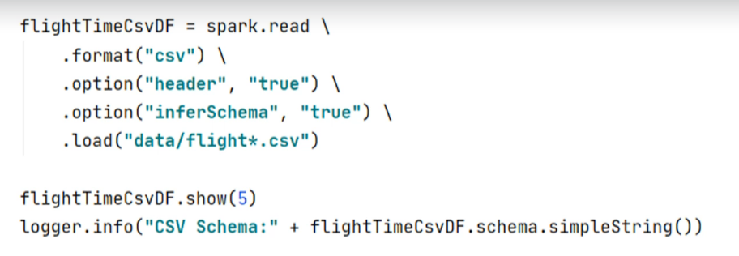

* If you point to a specific directry, Spark will read all the files present in that directory
* We can use wild cards as well

Loading a Json file: -

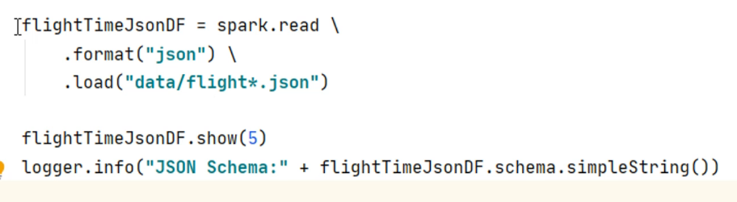

* No need to inferschema. For Json Spark does this automatically

Loading a Parquet file: -

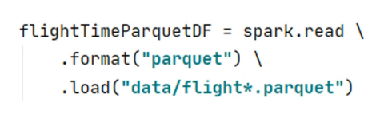

* No need to infer the schema as Parquet files comes with the schema itself
* It is recommended to use Parquet file with Spark

Most common Spark data types: -

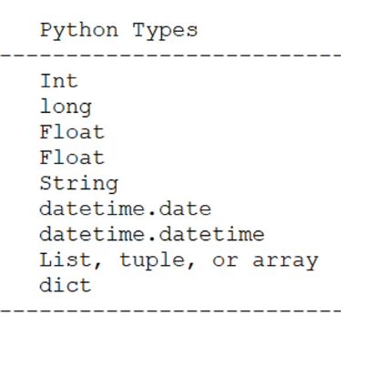

How to Programmatically define a schema: -

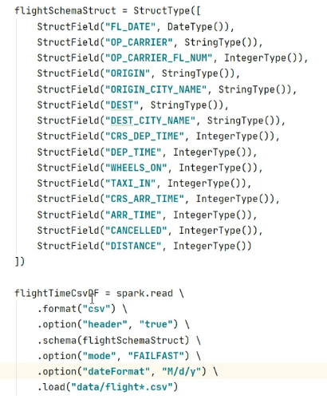

For Date datatype we need to provide a date-format during loading the data

DDL method of creating a schema: -



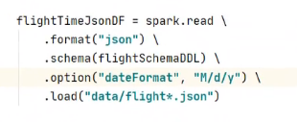

Writing data in spark: -

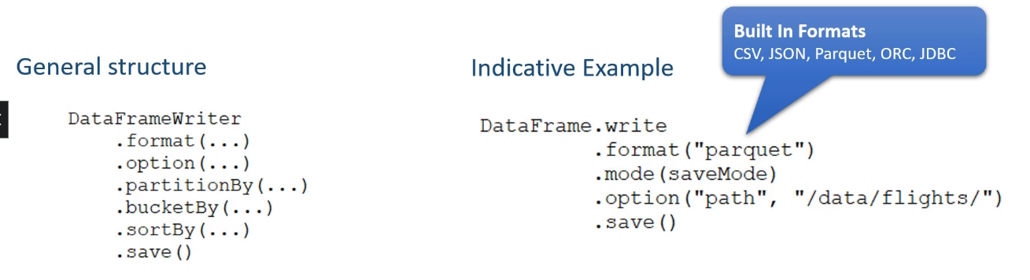

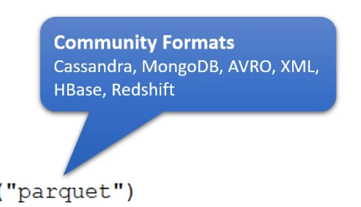

Ignore – will create the files if the target directory is empty otherwise it will do nothing

ErrorIfExists – if directory is not empty throws an error

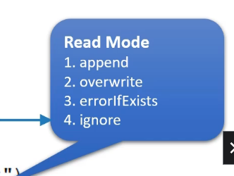

Finding number of partitions we have and how many records each partition possess: -



Repartitioning the data: -

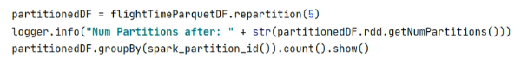

* Repartitioning is important because it may happen some of the partitions don’t contain any data

Partitioning the data during write operation: -

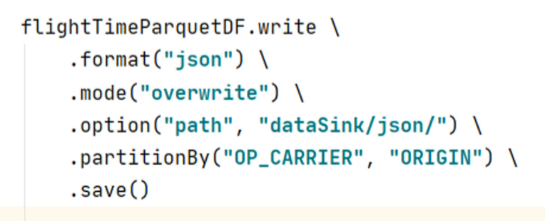

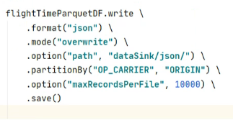

Spark Database and Tables: -

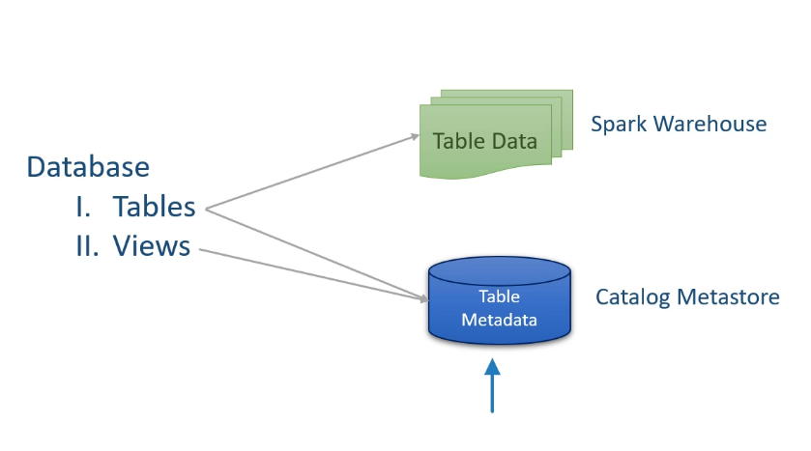

Spark Tables: -

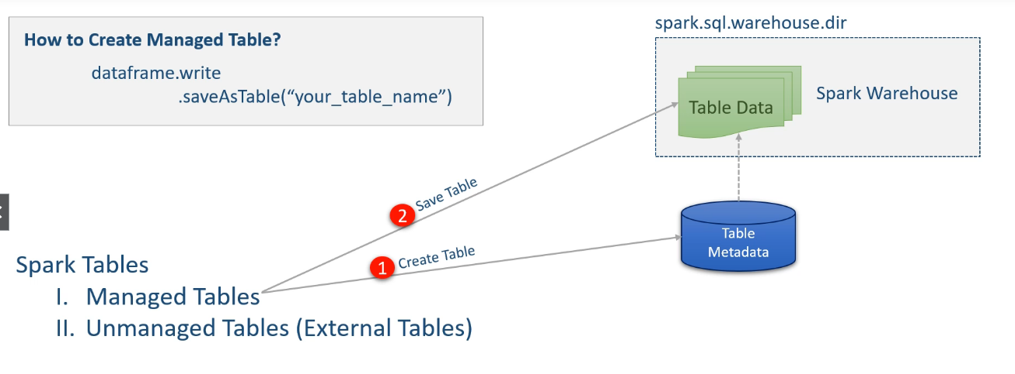

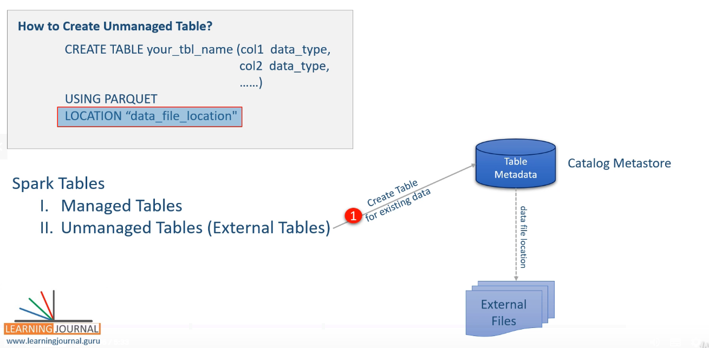

Managed and Unmanaged Tables: -

* Most of the behavior are same as Hive
* Managed table gives some additional benefits like Bucketing and sorting
* Managed tables are **accessible** to the external JDBC/ODBC connectors
* Spark uses **Hive meta store** to store the metadata

Creating a managed table: -

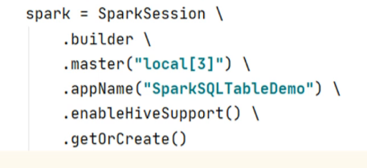

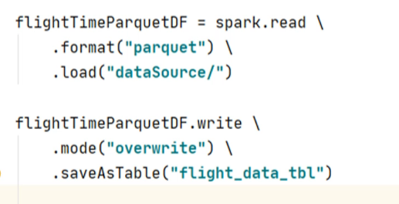

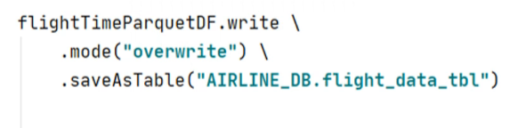

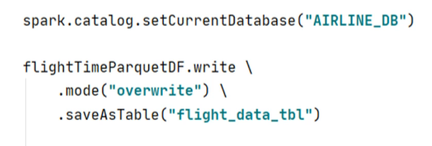

Creating a Database: -



Retrieving metadata information from the catalog: -





We need hive support to use metastore

It will create a table in the spark default database

Specifying the database, assuming database is already created

Another way

Creating partitioned table: -

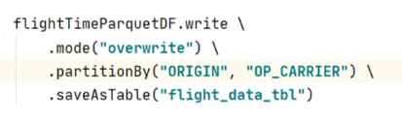

Bucketed and sorted table: -

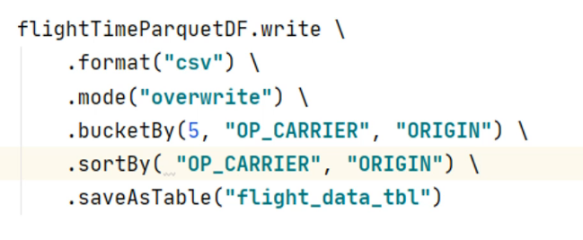

How bucketing happens: -

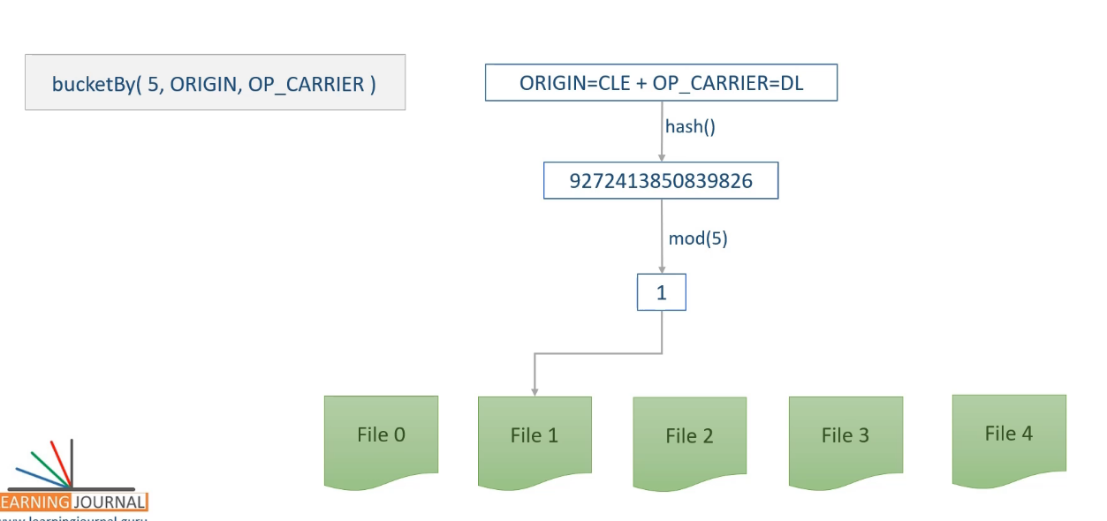

* Each bucket contains non-overlaping values

Spark Transformations: -

Working with dataframe Rows: -

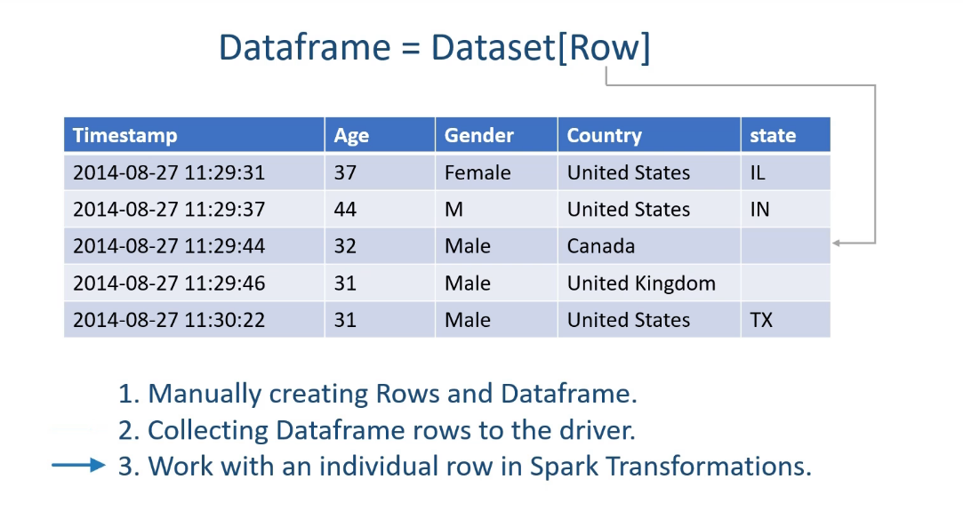

Date transformation: -

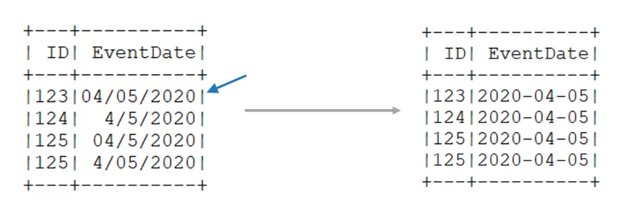

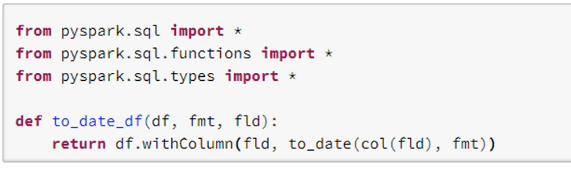

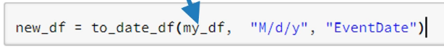

Need to change the datatype of the EventDate as well

If you use small sample files to test your function: -



Creating a dataframe on the fly: -

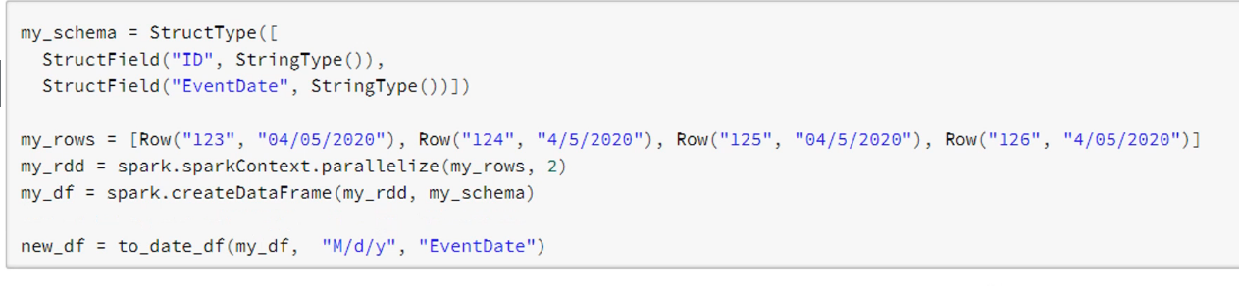

Some transformation functions: -

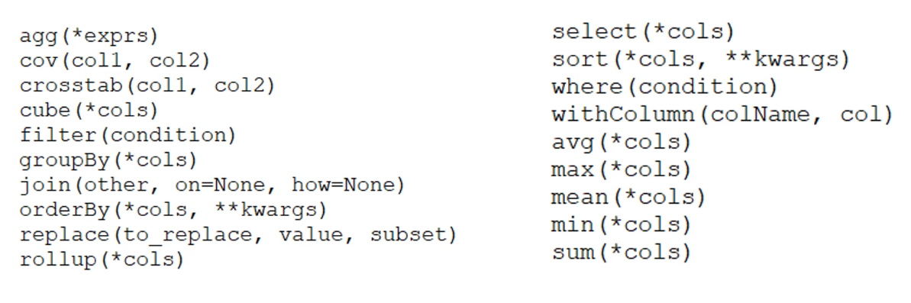

Extracting data using reguler expression (unstructured data): -

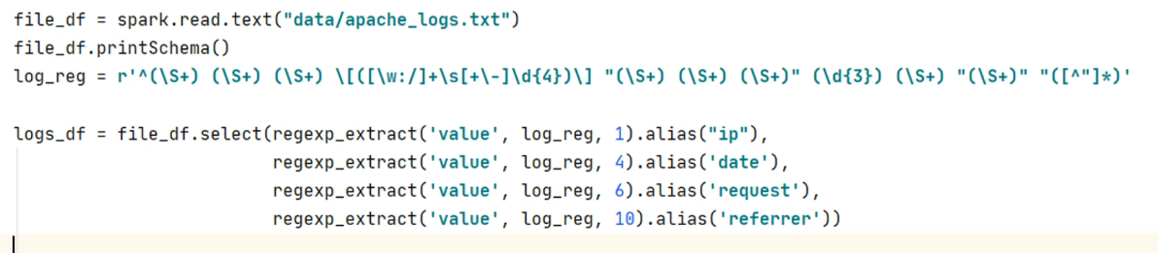

Working with column: -

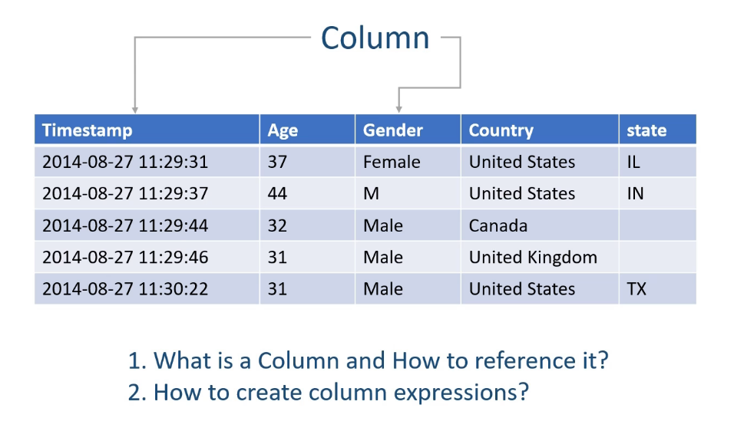

Use of sampling of data: -

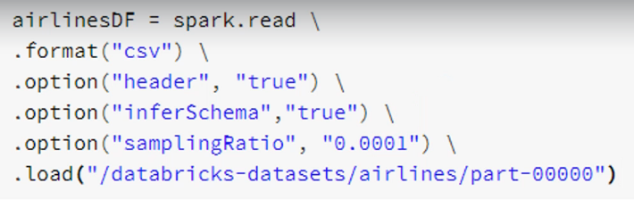

Access columns using column string: -



Access column using column object: -



* These three are same

How to create Column expressions: -

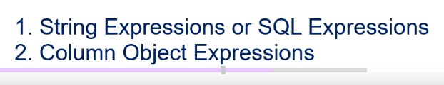

String expression or SQL expression: -



* expr function takes an expression and parse it and return an column object

Column object expression: -



Spark documentation ref: -

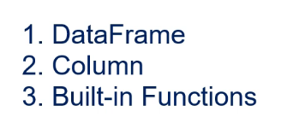

UDF’s : -

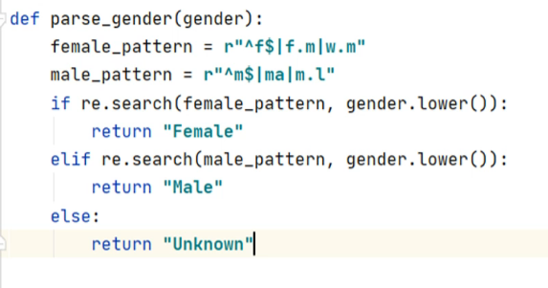

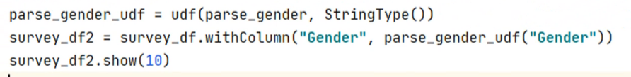

During UDF registration we can specify return type of the function but it is not mandatory

If you want to use your function in sql expression: -

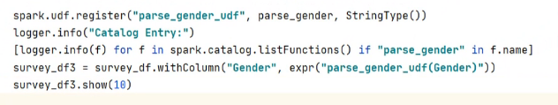

Creating a dataframe for testing: -

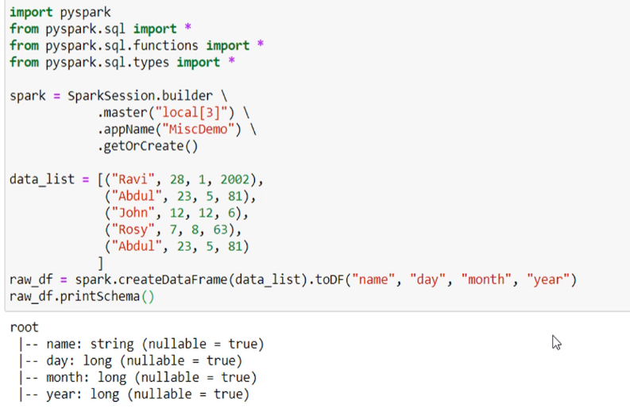

Adding monotonically increasing id: -

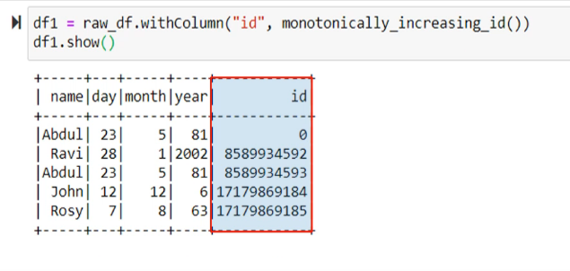

Don’t expect consecutive values but all the values will be different across all the partitions

Case statement: -

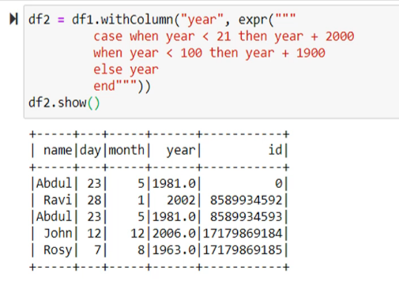

Type casting:

Inline cast: -

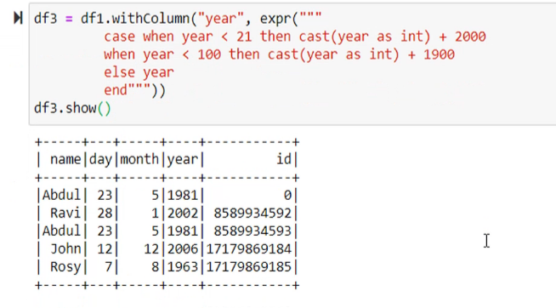

Change the schema: -

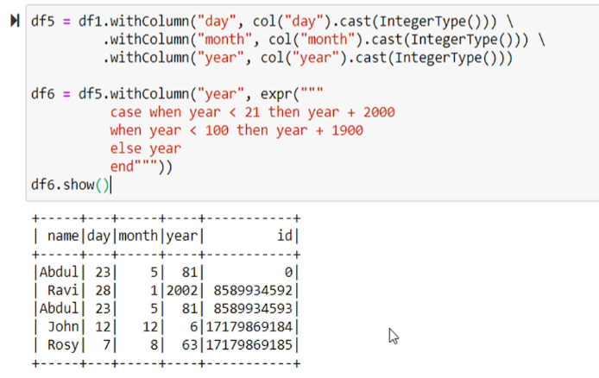

Case statement with column objects: -

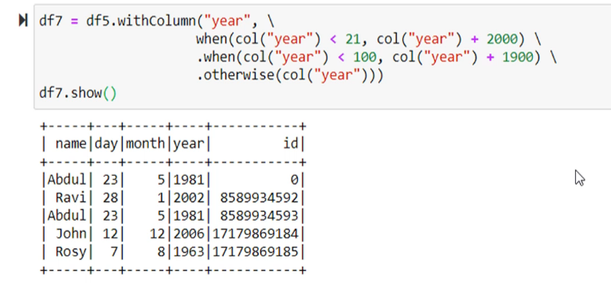





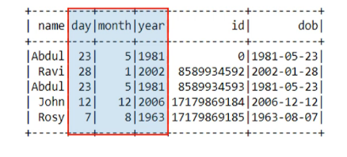

Drop some column: -

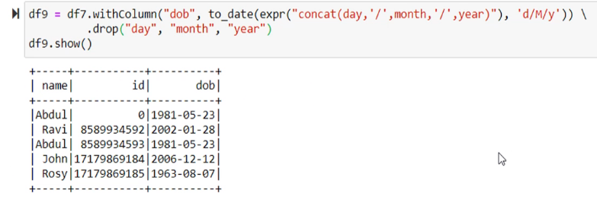

Dropping duplicates and sorting in descending order: -

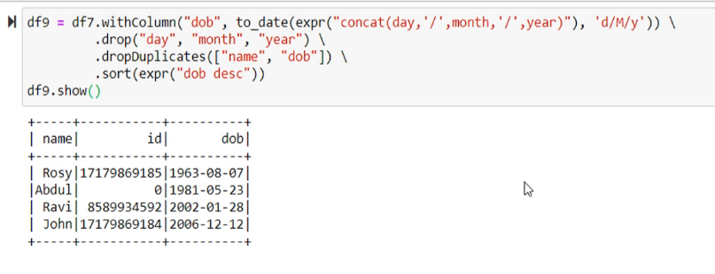

Aggregating dataframes: -

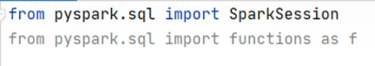

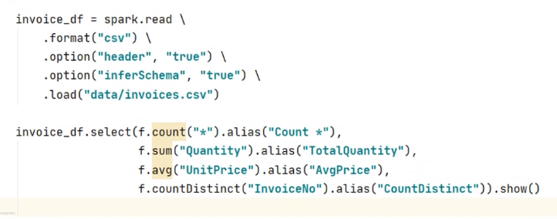

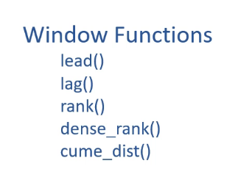

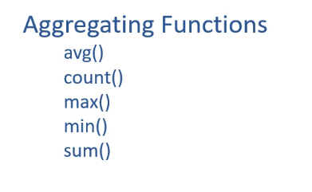

Using SQL expression: -

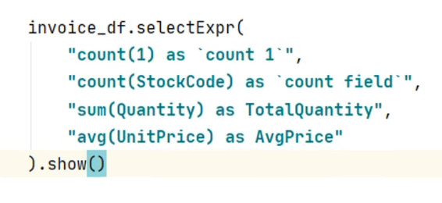

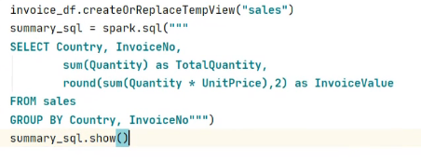

Dataframe expression: -

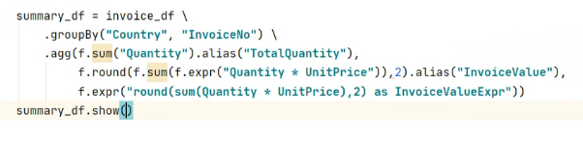

* Count(* or 1..) => count nulls also
* Count(field_name) => don’t count null

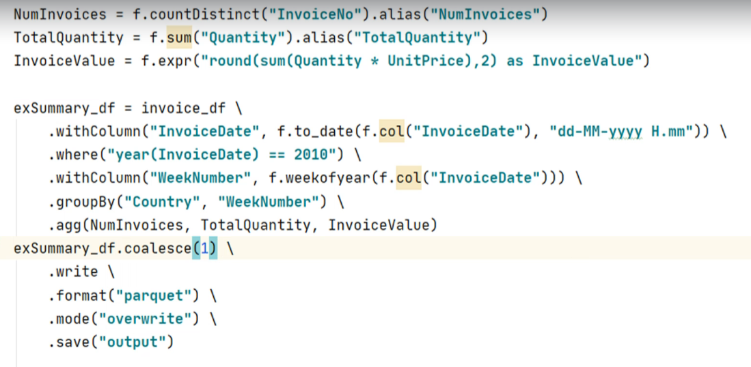

Windowing Aggregations: -

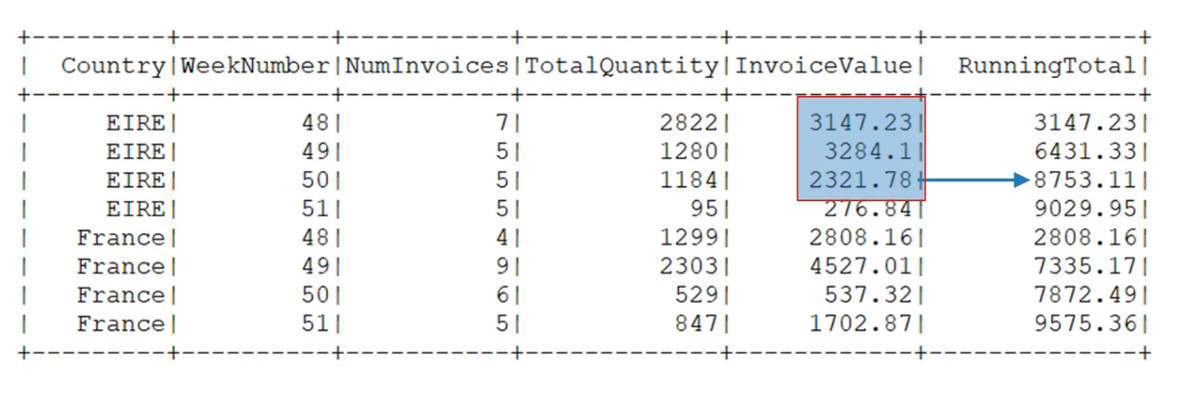

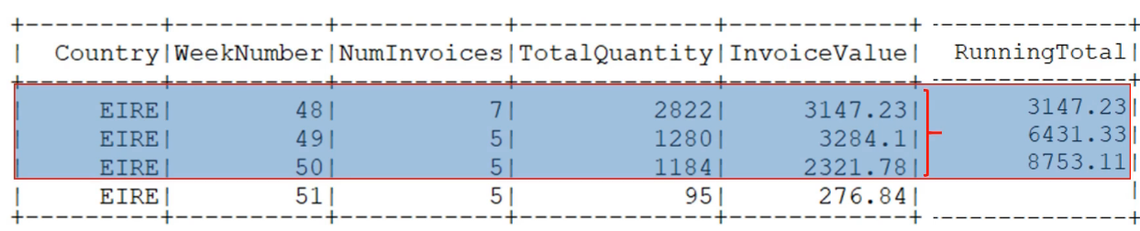

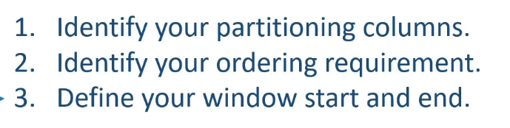

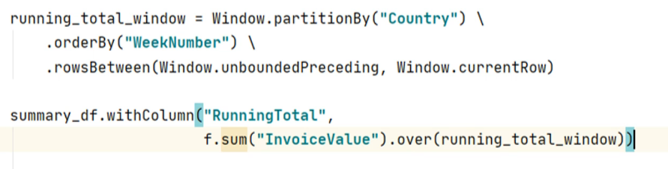

Joining two dataframes: -

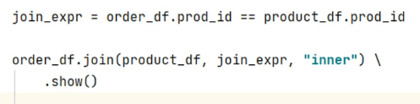

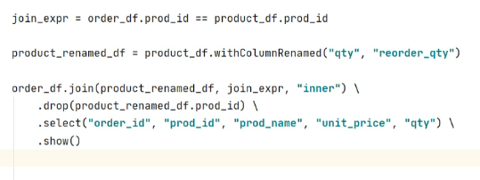

Full outer join: -

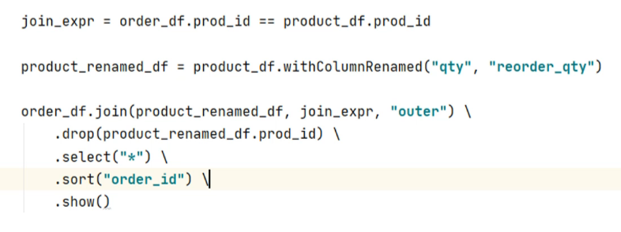

Feft outer join: -

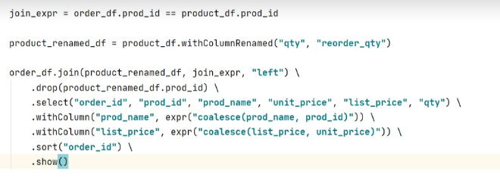

Join Internals: -

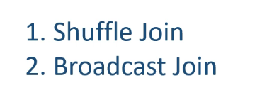

Optimizing joins: -

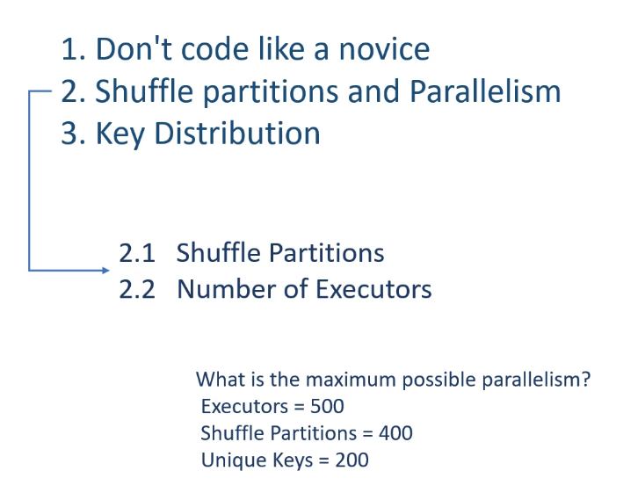

Configuring shuffle partitions: -



Common join problems: -

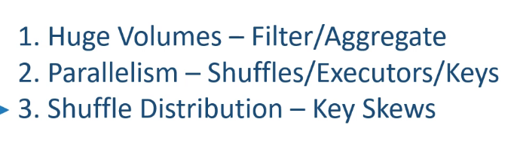

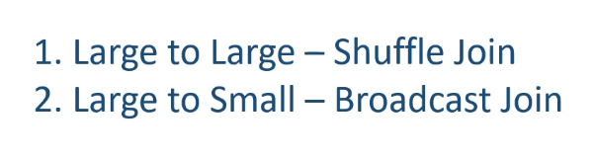

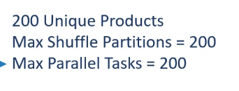

For broadcast join: -

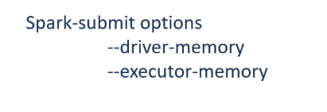

Implementing broadcast join: -

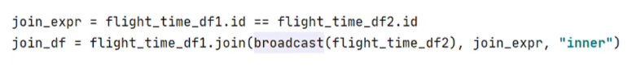

Implementing Bucket join: -

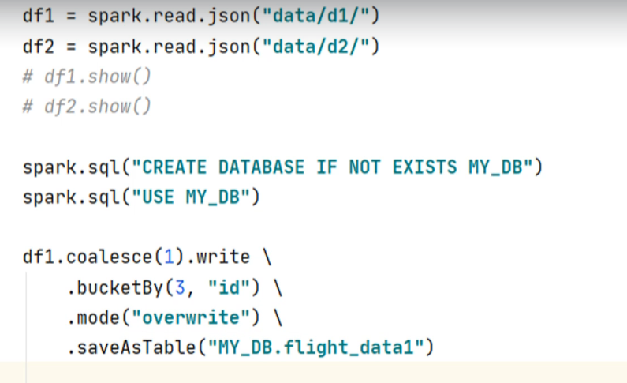

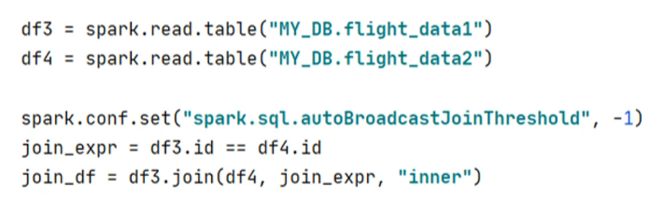

* autoBrodcastJoinThreshold is not required in actual case
* Spark is smart enough to fegerout when to use Broadcast join but for this example we don’t want that